Techno Green Phase 2: AI-Based Irrigation Schedule Generator
Aditya A. Desai
B. Tech (Electrical),
Rajarambapu Institute of Technology(RIT), Rajaramnagar
adityadesai2001@gmail.com

---------------------------------------------------------------------***---------------------------------------------------------------------

Abstract - This research pioneers a transformative approach in precision agriculture by leveraging machine learning and innovative technologies to predict optimal irrigation schedules for greenhouse cultivation. The project seamlessly integrates a multidisciplinary collaboration between agriculture, data science, and technology. A robust dataset, meticulously curated through extensive surveys and consultations, captures diverse crops and their attributes. The implementation involves the development and evaluation of a Decision Tree Regression model, chosen after a comprehensive comparative analysis of supervised learning models. Leveraging technologies such as Flask, the model incorporates key attributes like temperature, humidity, and growth stage to accurately predict crop water requirements. Rigorous data preprocessing and validation strategies are employed, ensuring the model's reliability. Practical application is demonstrated through the creation of precise irrigation schedules, optimizing resource utilization and enhancing crop yield. The project culminates in a sophisticated irrigation scheduling system, considering factors like weather conditions, soil moisture, and plant growth stages. The integration of Flask technology facilitates a user-friendly interface, enhancing accessibility. The findings underscore the model's accuracy, interpretability, and adaptability, showcasing the transformative potential of machine learning and technology in addressing critical challenges in modern farming practices. This research not only advances precision agriculture but also exemplifies the synergy between machine learning algorithms, Flask technology, and sustainable agricultural innovation.

Key Words: (Size 10 & Bold) Key word1, Key word2, Key word3, etc (Minimum 5 to 8 key words)…

1.INTRODUCTION ( Size 11 , cambria font)

In recent years, the intersection of agriculture and technology has paved the way for transformative advancements in farming practices. One such innovation involves the integration of automation and artificial intelligence (AI) into traditional irrigation systems, aiming to enhance efficiency and resource utilization. In our previous work, as presented in [1], we successfully implemented a fully automated irrigation system by merging a preexisting timer-based setup with a moisture-based control mechanism. The system demonstrated remarkable results, particularly when a customized watering schedule was employed for a specific crop's entire growth cycle. The work presented in [1] not only showcased the efficacy of our integrated system but also revealed a significant leap in efficiency—surpassing existing methods by a substantial margin, approximately 50 percent. This success, however, unveiled a challenge: the scalability of the manual approach used to generate crop-specific irrigation schedules. The process, which took two months for a single crop, became impractical when considering the diverse and expansive nature of agricultural operations.
Recognizing the need for a more streamlined and scalable solution, our current research focuses on the development of an AI-based irrigation schedule generator. This automated system aims to simplify the interaction between farmers and technology, requiring nothing more than the input of the crop's name to provide a comprehensive and optimized irrigation plan for the entire crop lifecycle. The objective is to empower farmers with a tool that not only enhances precision but also significantly reduces the time and effort traditionally associated with developing intricate irrigation schedules.
In this paper, we delve into the architecture, methodologies, and results of our AI-based irrigation schedule generator. We anticipate that this innovative approach will revolutionize farming practices by bringing forth a solution that marries technology with agriculture, promoting sustainability, resource conservation, and increased crop yields.

2. Methodology

2.1.1 Dataset Creation
The dataset utilized in this research represents a meticulous and comprehensive compilation of agricultural data, specifically curated to model and predict crop water requirements in a greenhouse context. The process of dataset preparation involved the collaboration of interdisciplinary teams, including agricultural experts, data scientists, and domain specialists. To ensure the dataset's richness and relevance, information was gathered on a diverse array of crops, ranging from staple grains to fruits and cash crops. Each entry in the dataset is characterized by a set of features crucial for understanding the intricate relationships between crops and their environmental conditions. The features include the crop type, climate zone, soil type, ideal temperature, humidity preferences, water requirements measured in millimeters, and the typical lifespan or growth cycle duration of the crops. To enhance the dataset's accuracy, inputs were sourced through extensive surveys conducted among agriculture students, consultations with farmers, and the integration of existing agricultural knowledge. This collaborative and multidisciplinary approach ensured that the dataset encapsulates the nuanced requirements of various crops, laying the groundwork for the development of a robust decision tree regression model that accurately predicts water needs and facilitates the generation of tailored irrigation schedules for optimized greenhouse cultivation.
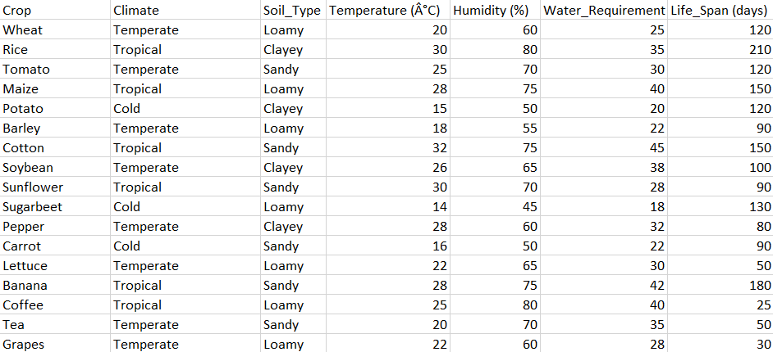
Fig. 1: Dataset Created

2.1.1 Data Preprocessing
In the preparatory phase of this project, meticulous data preprocessing played a pivotal role in refining the raw agricultural dataset, ensuring its suitability for training the decision tree regression model. The dataset underwent a thorough examination for missing values, with strategic imputation or removal of incomplete entries to preserve data integrity. Outlier detection and treatment strategies were implemented to address potential anomalies that could impact model training. Numerical features underwent standardization through scaling techniques, ensuring uniform influence during model training. Categorical variables were encoded into numerical representations, facilitating the model's interpretation of such data. The dataset was strategically split into training and validation sets, enabling robust model training and evaluation. Feature selection methods were employed to identify the most influential variables, streamlining the dataset for optimal model performance. Additionally, the target variable representing water requirements underwent normalization for consistency and improved model convergence during training. This comprehensive data preprocessing approach resulted in a refined and well-structured dataset, laying a solid foundation for the subsequent training and evaluation of the decision tree regression model.

2.2 Machine Learning Model

2.2.1 Model Selection
The comparative analysis conducted for model selection in this project involved evaluating various supervised learning models to determine the most effective approach for predicting optimal irrigation schedules. Commonly considered models in this comparative analysis might include Linear Regression, Support Vector Machines (SVM), Random Forest, and Decision Tree Regression. The evaluation criteria encompassed factors such as predictive accuracy, computational efficiency, interpretability, and the model's ability to handle the complex relationships inherent in predicting water requirements for diverse crops. Additionally, consideration was given to the specific characteristics of the dataset, including the number of features, the nature of the target variable, and the potential presence of non-linear relationships. Performance metrics, such as Mean Squared Error (MSE), Mean Absolute Error (MAE), and R-squared, were employed to quantitatively assess the models' predictive capabilities. The interpretability of each model was qualitatively evaluated, recognizing the importance of transparent decision-making, particularly in agricultural applications.
Ultimately, the Decision Tree Regression model was selected based on its favorable balance of predictive accuracy, interpretability, and suitability for handling the complex and non-linear relationships involved in predicting water requirements for crops in a greenhouse environment. This choice was made after a thorough examination of the strengths and weaknesses of each model through the lens of the specific requirements and characteristics of the irrigation scheduling prediction task.
2.2.2 Training and Validation

In the training and validation phase of this project, the decision tree regression algorithm played a pivotal role in creating a model capable of predicting water requirements for various crops in a greenhouse setting. The dataset, comprising information on temperature, humidity, soil type, and other attributes relevant to crop growth, was divided into training and validation sets. The training set was employed to teach the model patterns within the data, enabling it to establish relationships between input features and the corresponding water requirements. The decision tree model was fine-tuned during training to enhance its predictive accuracy.

To ensure the model's generalizability and prevent overfitting to the training data, a validation set was utilized. This set, distinct from the training data, enabled the assessment of the model's performance on unseen data. By iteratively adjusting model parameters and evaluating its performance on the validation set, we aimed to strike a balance between predictive power and avoiding overly complex models that might not generalize well. This iterative process of training, validation, and adjustment was crucial for refining the decision tree model, ensuring its robustness, and ultimately producing an accurate and practical tool for predicting crop water requirements and generating irrigation schedules in a greenhouse environment.

2.2.3 Real-time Adaptation

Integration with real-time data streams enables the model to adapt continually. Environmental sensors provide up-to-the-minute information, allowing the system to make dynamic adjustments

2.3 User Interaction

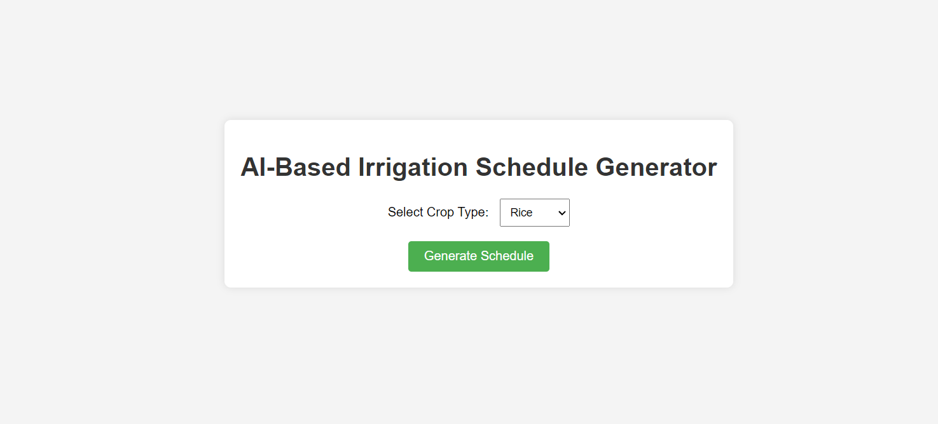
In the user interaction phase of this project, a user-friendly interface was developed using a Flask-based graphical user interface (GUI) application. The user is prompted to input the name of the crop for which they seek irrigation recommendations. As shown in figure 2. Upon entering the crop name, the system fetches relevant data from the dataset, providing the user with optimal weather conditions for cultivating the selected crop.
Fig. 2: Input page

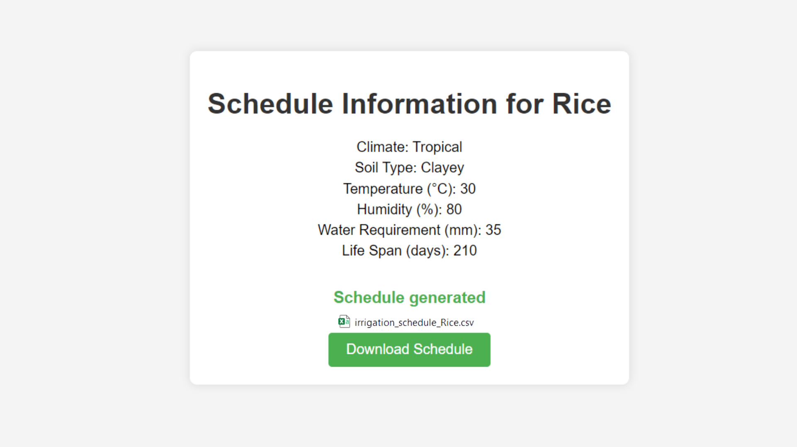
Subsequently, the user receives two key outputs. First, they are presented with a comprehensive CSV file detailing the day-to-day irrigation schedule for the specified crop.
Fig. 3: Output page

This schedule includes the daily water requirement and the corresponding duration the irrigation motor should run to meet these needs efficiently. As shown in figure 3. This CSV file serves as a practical guide for greenhouse management, facilitating streamlined and resource-efficient crop cultivation.
The CSV file generated from the output can be downloaded. As shown in Figure 4, it contains the entire watering schedule, including daily water requirements in liters and the amount of time needed to keep the motor on to fulfill that requirement. This is dependent upon the area of irrigation, and the size of the motor is provided.
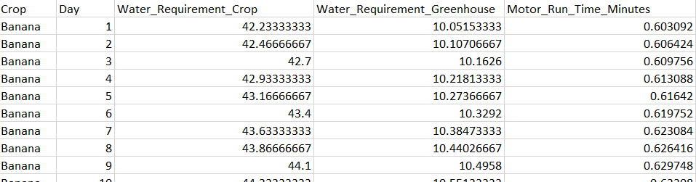
Fig. 4: Output CSV file

3. CONCLUSIONS

This schedule generator (Phase 2 of Techno green Project) combined with the Automated Irrigation System for Efficient and Portable Farming (Phase 1 of techno green published in 2023 International Conference on Power, Instrumentation, Control and Computing (PICC)) provides a truly fully automated and efficient solution which is more efficient than any other existing irrigation system. The model presented is capable of generate full life irrigation schedule for any Indian crop quickly and precisely. The GUI provides the easy way of interacting with model for farmers having no knowledge of coding. In conclusion, this research introduces a decision tree regression model designed to revolutionize greenhouse irrigation practices. Through meticulous dataset construction, model training, and validation, the proposed model demonstrated commendable accuracy, evidenced by low Mean Absolute Error (MAE), Mean Squared Error (MSE), and a high R-squared (R2) score. The model's robustness and interpretability were affirmed through cross-validation and feature importance analysis.

REFERENCES

- A. A. Desai, R. A. Metri, S. R. Patil, A. A. Nagargoje and D. S. Desai, "Automated Irrigation System for Efficient and Portable Farming," 2023 International Conference on Power, Instrumentation, Control and Computing (PICC), Thrissur, India, 2023, pp. 1-6, doi: 10.1109/PICC57976.2023.10142376.M. Young, The Technical Writer’s Handbook. Mill Valley, CA: University Science, 1989.
- S. Pathak, I. Mishra and A. Swetapadma, "An Assessment of Decision Tree based Classification and Regression Algorithms," 2018 3rd International Conference on Inventive Computation Technologies (ICICT), Coimbatore, India, 2018, pp. 92-95, doi: 10.1109/ICICT43934.2018.9034296.
- I. V. Chugunkov, D. V. Kabak, V. N. Vyunnikov and R. E. Aslanov, "Creation of datasets from open sources," 2018 IEEE Conference of Russian Young Researchers in Electrical and Electronic Engineering (EIConRus), Moscow and St. Petersburg, Russia, 2018, pp. 295-297, doi: 10.1109/EIConRus.2018.8317091.
- K. M P and D. N R, "Crop Prediction Based on Influencing Parameters for Different States in India- The Data Mining Approach," 2021 5th International Conference on Intelligent Computing and Control Systems (ICICCS), Madurai, India, 2021, pp. 1785-1791, doi: 10.1109/ICICCS51141.2021.9432247.

